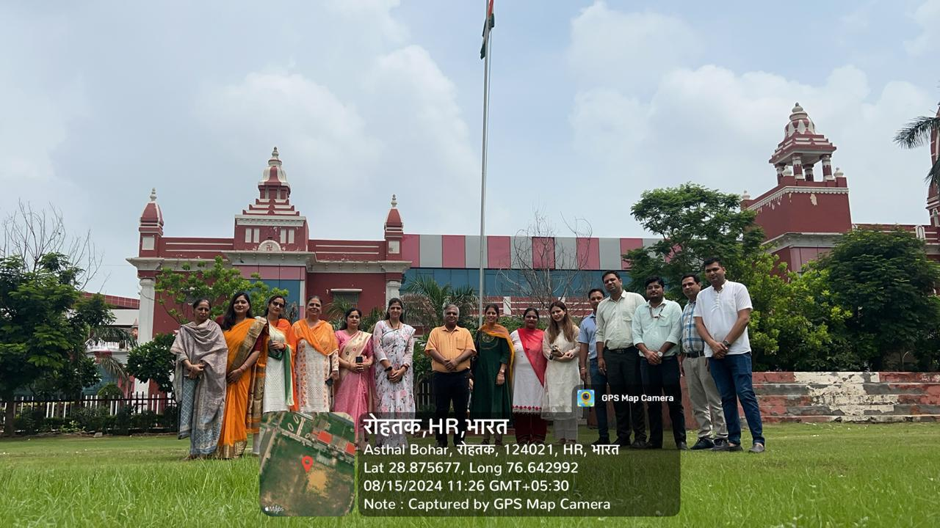
PROPOSED PROGRAMME AYURVEDA WEEK – 2024
DATE | ACTIVITIES | COORDINATOR
18.10.2024 | Health checkup & health Awareness camp at SBMN Sainik School | Dr Amit Yadav, Dr Monika and Dr Gaurav Dalal
19.10.2024 | Health checkup & health Awareness camp at SBMN Residential School | Dr Amit Yadav, Dr Monika and Dr Gaurav Dalal
21.10.2024 | Health Awareness lecture in Humanities College | Dr Gaurav Dalal, Dr Nitin Jain, Dr Rahul
22.10.2024 | Health Awareness lecture in Pharmacy College and science department | Dr Gaurav Dalal, Dr Nitin Jain, Dr Rahul
22.10.2024 | 1. Yogaasana Competition | Dr. Gourav Dalal, Dr. Shikha
22.10.2024 | - Awareness Lecture | Dr. Gourav Dalal, Dr. Shikha
22.10.2024 | - Plantation | Dr. Pooja Rohilla and Dr. Nitin Jain
23.10.2024 | Indoor Games  1. Badminton  2. Table tennis  3. Chess  4. Carrom | Dr Amit Kumar Yadav  Dr Anita  Dr. Rahul  Dr. Nitin Jain  Dr. Rakesh  Dr. Gourav Dalal
24.10.2024, 25.10.2024 | Outdoor Games  - Run (100 M and 200 M)  - Volley Ball  - Cricket  - Throw Ball (for female only)  - Tug of War  - Long Jump | Dr Amit Kumar Yadav  Dr Anita  Dr. Rahul  Dr. Nitin Jain  Dr. Rakesh  Dr. Gourav Dalal
26.10.2024, 27.10.2024 | 1. Rangoli competition | Dr. Amrit and Dr. Berkha
26.10.2024, 27.10.2024 | 2. Poster Competition | Dr. Deepti and Dr. Monika
26.10.2024, 27.10.2024 | 3. Mehandi Competition | Dr. Preeti and Dr. Sangeeta
26.10.2024, 27.10.2024 | 4. Flameless cooking and Millet recipe preparation competition | Dr. Austluxmi and Dr. Rakesh
26.10.2024, 27.10.2024 | 5. Quiz Competition | Dr. Sapna and Dr. Rahul
28.10.2024 | - Cultural  1. Solo dance  2. Group dance  3. Poetry  4. Singing  5.Ramp Walk  Prize Distribution Function | Dr. Sonam & All Cultural Committee  Dr Anita  Dr Sapna  Dr Amit  Dr Rahul  Dr Austluxmi
29.10.2024 | 1. Dhanwantri Pooja | Dr. Jagdish Acharya  Dr. Pooja Rohilla  Dr Raj Kailash  Dr. Nisha Jaglan  Dr. Amrit  Dr. Anita Yadav  Dr. Amit Yadav  Dr. Rakesh  Dr. Nitin Jain  Dr. Gourav Dalal

Independence day2024 (78th)
Today we celebrated the78th Independence Day with great enthusiasm and pride. The event began with the hon’ble vice chancellor, prof. H, L. Verma, hoisted the tricolor, accompanied by Registrar Dr. Manoj Verma and Dean Student welfare, Dr. Sudhir Malik.
The spirit of patriotism was further elevated by a remarkable parade performed by our NCC cadets both boys and girls marching in unison. The entire campus resonated with the energy and devotion of our students and staff, who were all present to witness this memorable event.
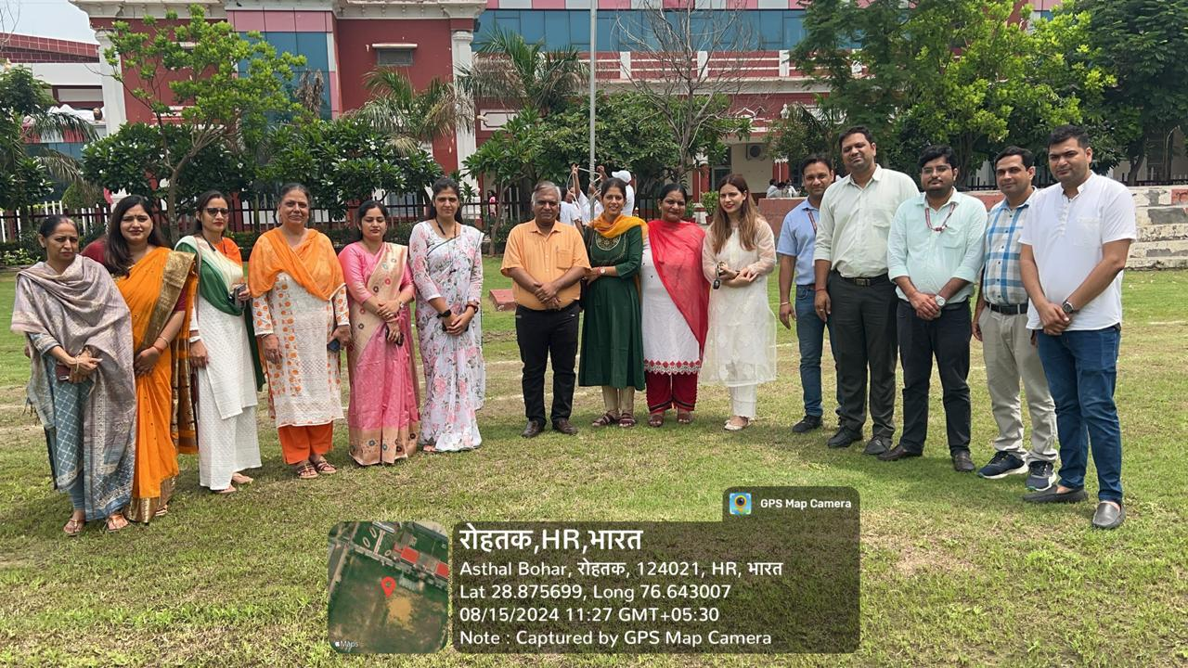
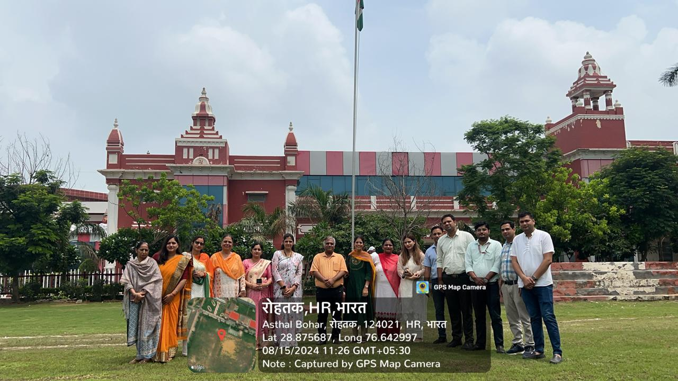
Following the flag unfurling, a vibrant cultural program was organized by the Dean Student's Welfare & Faculty of Engineering. Students from various departments showcased their talents through captivating performances that highlighted our nation's rich cultural heritage.
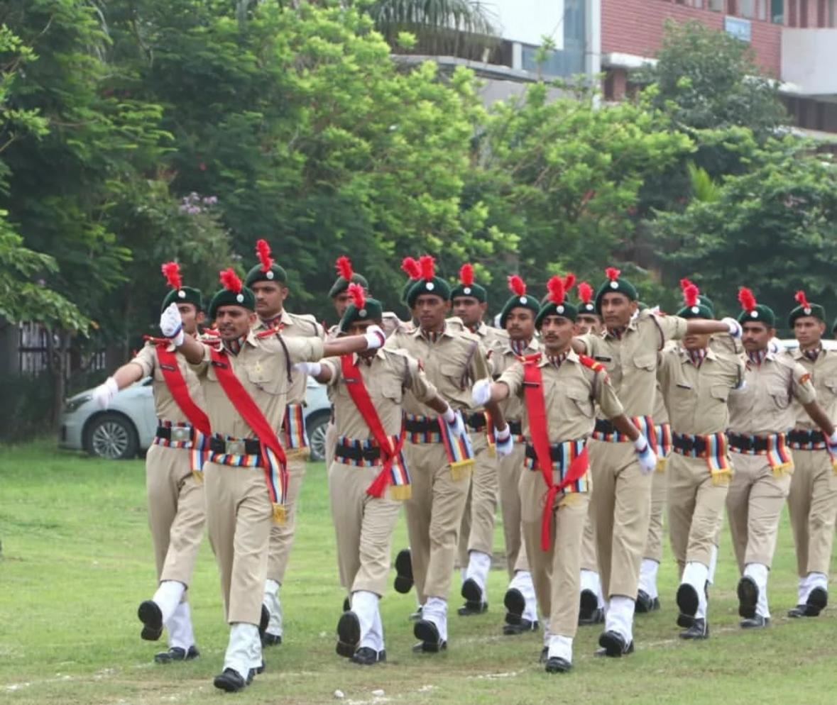
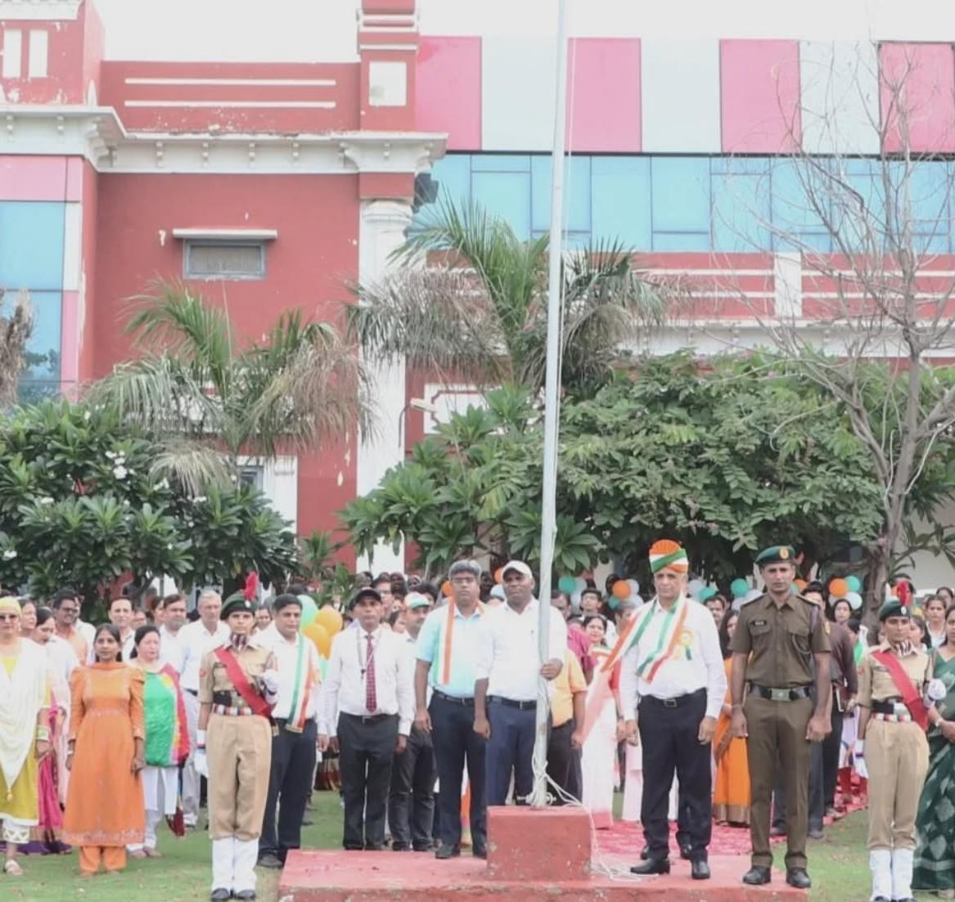
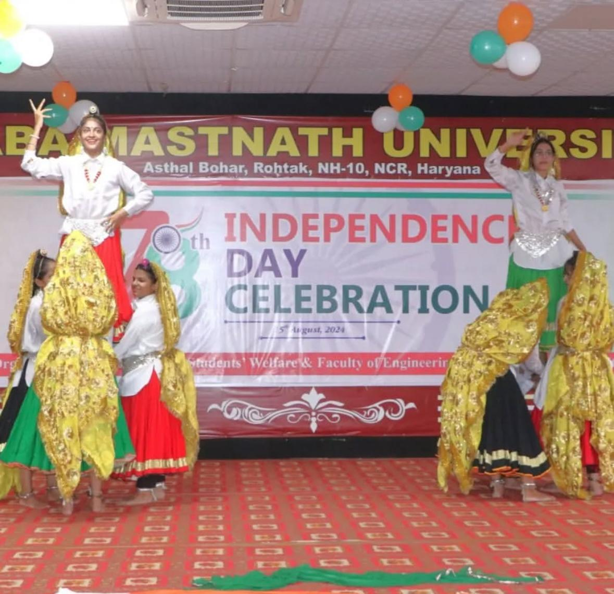
A heartfelt salute to everyone who made this day special! Let's continue to strive for a brighter, stronger, and more united India!

